Coast Guard Cutter Midgett part of commemoration of the Bombing of Dutch Harbor

By Seaman Samuel Rodriguez (USCGC Midgett), Phil Johnson (NLUS Lake Washington & Everett Council), Coast Guard District 17 Public Affairs
USCG photos

(Dutch Harbor, Alaska) -- People from all over the U.S. gathered recently to remember an important but often forgotten piece of American history. June 3rd, 2017 marked the 75th anniversary of the Bombing of Dutch Harbor during World War II. A Japanese aircraft carrier launched air attacks against Dutch Harbor Naval Base and Fort Mears. The attacks on Pearl Harbor and Dutch Harbor stand as the only Japanese attacks on American soil.

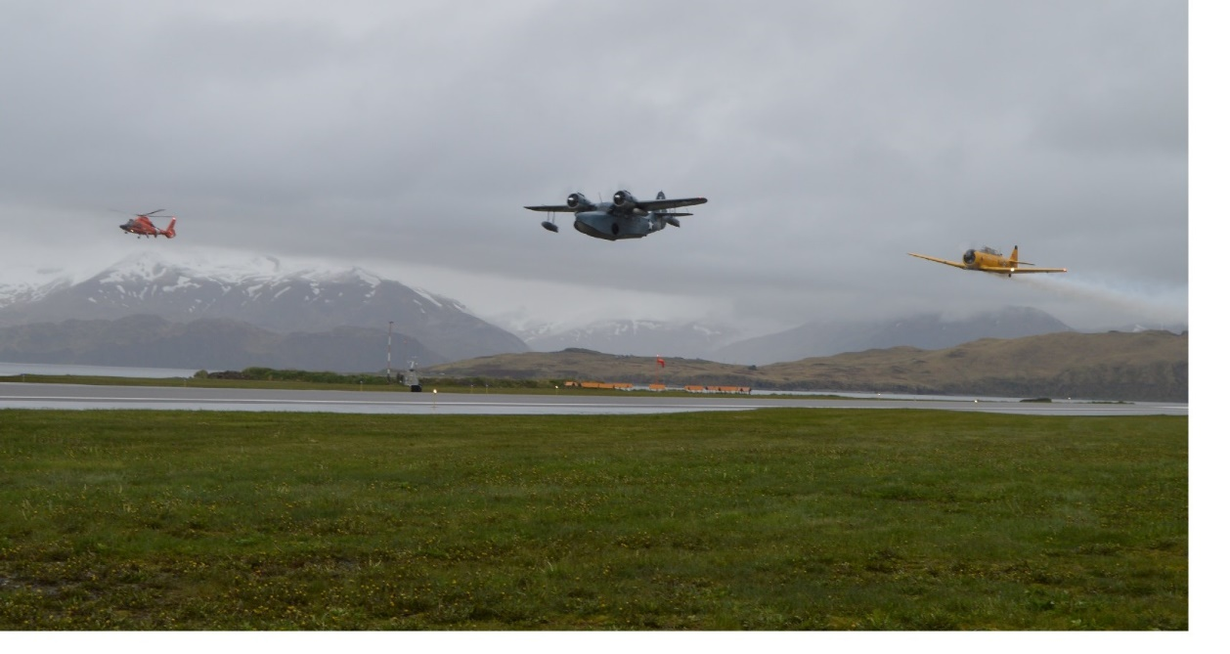
Coast Guard Cutter Midgett’s aviation detachment conducts a flyover alongside historic World War II aircraft, a Grumman JRF-5 Goose and a Canadian Harvard MK IV training plane, in Dutch Harbor, Alaska, June 3, 2017.

A memorial ceremony was held June 4th to commemorate the bombings. Alaska U.S. Senator Lisa Murkowski, Governor Bill Walker, and Unalaska Mayor Frank Kelty spoke about the significance of the event. Midgett’s Commanding Officer, Captain Teri Jordan, participated in laying wreaths to honor the fallen during the ceremony.

“It was an honor to participate in this important event with the residents of Dutch Harbor and all the returning World War II veterans and Aleut evacuees whose lives were impacted during the attack and occupation of the Aleutian Islands,” said Jordan. “The challenges faced during this historic time highlighted the strength and versatility of the Alaskan natives and those who called the Aleutian Islands home. It was truly an honor for Midgett officers and crew to assist the community in paying tribute to those American heroes."

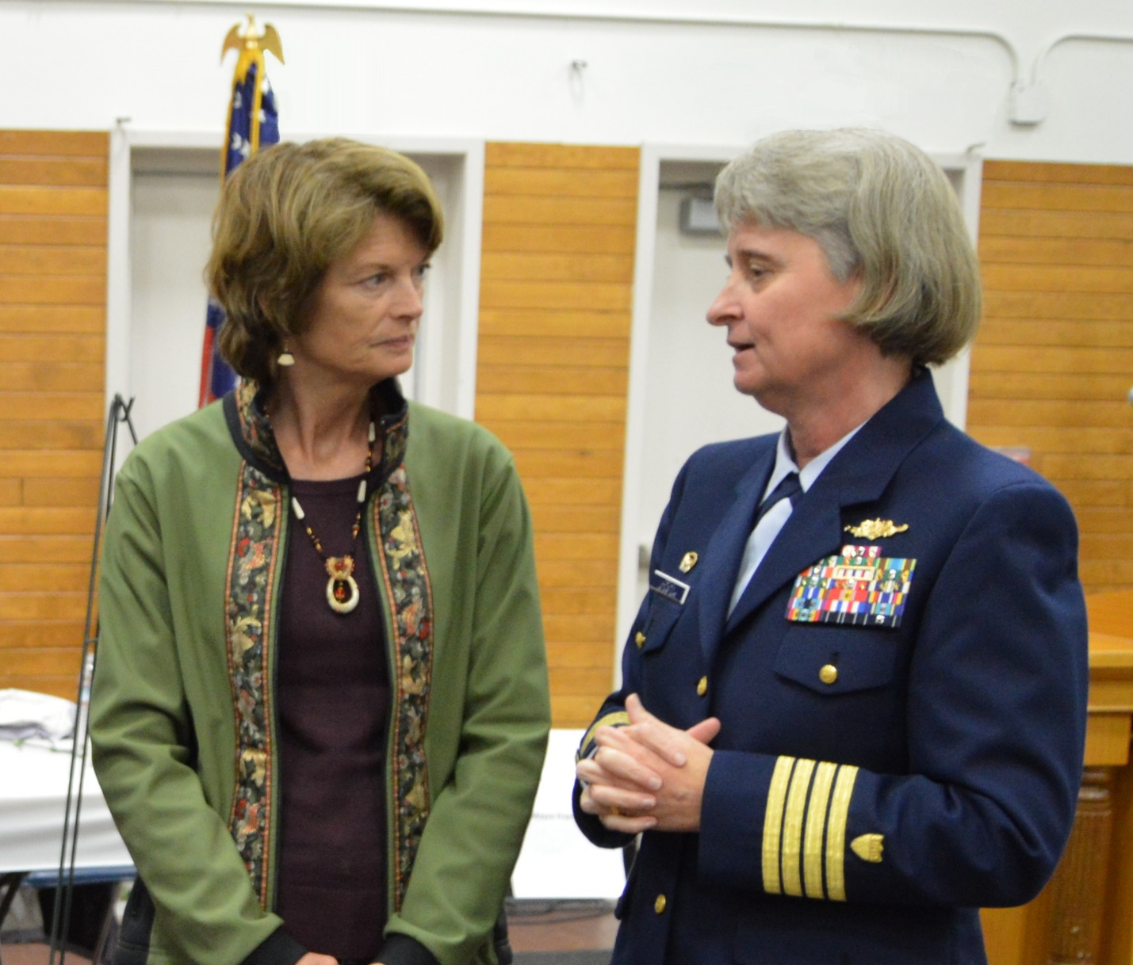

U.S. Senator Lisa Murkowski and USCGC Midgett CO, Captain Teri Jordan, discuss the Dutch Harbor 75th anniversary observance.

After mooring in Dutch Harbor, Midgett opened for public tours. Civilians were shown what life is like on a large Coast Guard cutter, including the numerous duties necessary to operate and maintain the ship.

Volunteer crew members also provided shuttle service for visiting World War II veterans and Aleut evacuees, allowing them convenient transportation throughout the city.
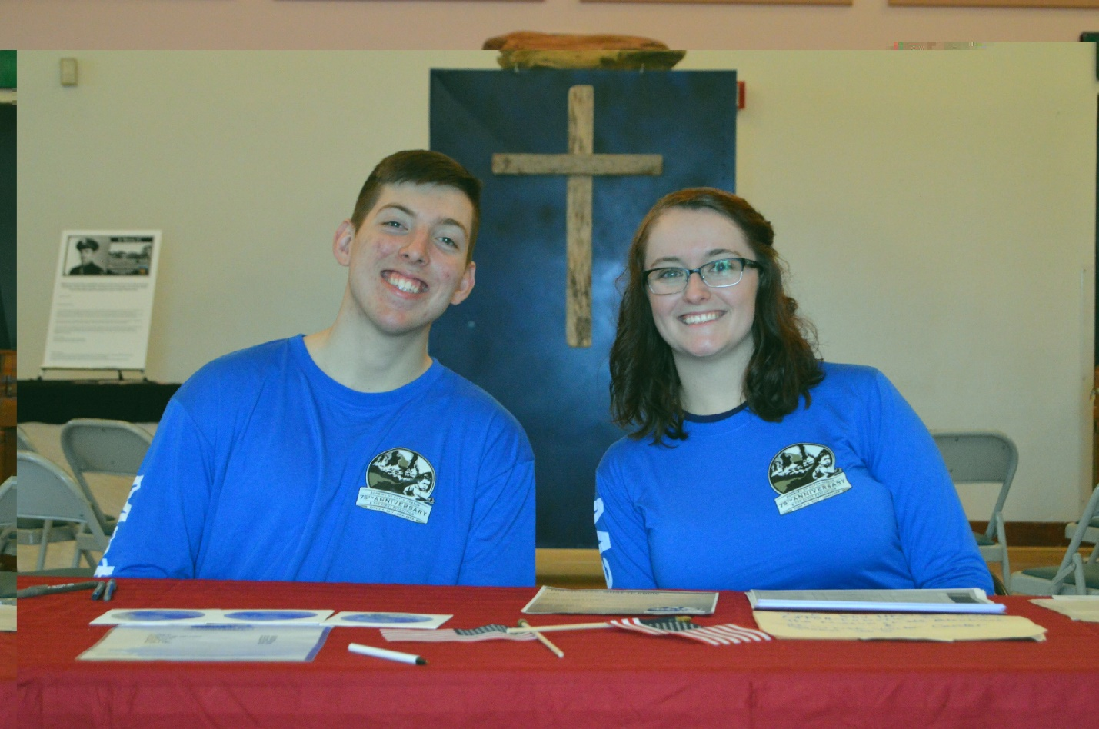

USCGC Midgett crew members provided shipboard tours and visitor transportation. Shown here are two of the volunteers, Seaman Zachary Cutburth and Petty Officer Brittany Filon.

For those interested in learning more a detailed history of the attack and Coast Guard activities in Alaska during WW II, here’s a link to comprehensive information, including historic photos:
https://www.uscg.mil/history/articles/USCGatWar-Alaska.pdf

