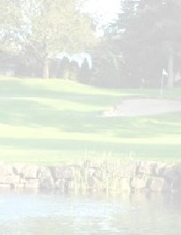
Navy League of the United States
Lake Washington - Everett Council
3rd Annual
Golf Scramble

Twin Lakes Golf
& Country Club
3583 SW 320th Street Federal Way, WA 98023

Thursday 18 May 2017
1130 - Sign in 1200 - Putting Contest 1300 - Shotgun Start
Buffet, Awards, Auction, and Prizes to Follow
Registration Deadline 30 April
$360/4 Golfer Team or $95/Per Golfer
&
$30 for those not playing golf

Register On-Line: https://lakewashnlus.org/event-2462213

Direct all questions to Kevin Isherwood at MEMBERSHIP.LWE@Gmail.com or (240)786-2775

Proceeds go to: Navy & Coast Guard MWR Programs and Families in NEED

